***Helland Players Present***

Who killed the hotel manager?

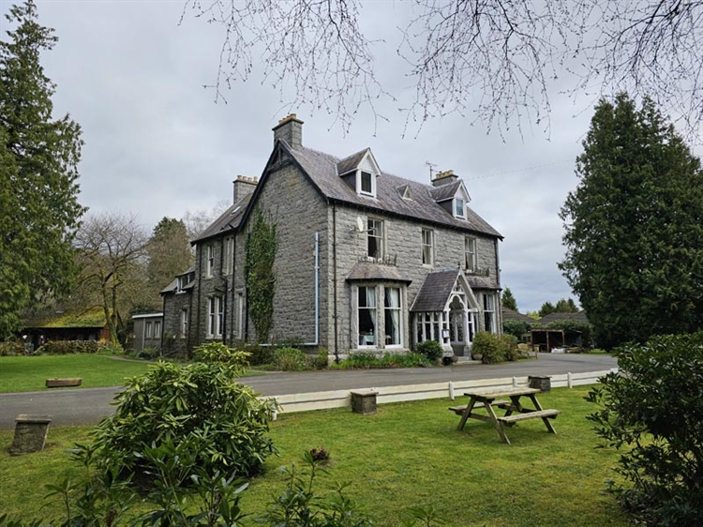A murder mystery evening!!

**Helland Village Hall 7.30pm**

**Friday 4th April Saturday 5th April**

**Friday 11th April Saturday 12th April**

**£13.50 including pasty supper. Licensed bar**

**Tickets: Jackie 07506 143 082**

Supporting Cornwall Air Ambulance, Cornwall Hospice Care and Helland Church