Media Consent Form (updated February 2024)
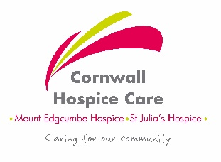
(Written interview, photography, video filming, sound recording)
Thank you for consenting to help Cornwall Hospice Care to promote our charity. By using interviews, photographs and film we can tell our story and ensure people understand what it is we do within the community of Cornwall.
Please read this information and sign below to confirm your consent:
- I understand that details I provide will be processed in accordance with the Data Protection Act and the UK GDPR. I understand that my story may be used more than once without restriction and without compensation to me.

- I agree to be photographed/filmed on video/recorded for sound purposes/quoted for a written article (circle all or any as appropriate) and I understand that the content may be used in various ways, including but not limited to; social media, local and national news outlets, internal charity news, charity promotional materials such as leaflets, bus stop and billboard adverts and on the Cornwall Hospice Care website.

- I have informed/will inform* my next of kin that I have agreed for all such material to be used for this purpose. (*delete as appropriate). If I am under the age of 18 years, my Parent/Legal Guardian has also signed below to give their permission.

- I agree that Cornwall Hospice Care will own the copyright of the content and that the consent will last for 5 years from the date on which this form is signed. Please note that after 5 years content may continue to appear in media posts and publications that were already in circulation.

- You have the right to ask the charity to stop using your image at any time, in which case it will not be used in future media projects but may continue to appear in media posts and publications that are already in circulation.

- I understand that my details will not be passed on to anyone else without my specific consent, using a new consent form (unless required by law).
Signed:…………………………………………. Date:………………………………………………………….
Full Name:…………………………………………………………………………………………………………
Relationship to Hospice:…………………………………………………………………………………………
Contact Phone Number (of Parent/Guardian if under 18):……………………………………………..
Contact Email (of Parent/Guardian if under 18):………………………………………………………….
Name of Parent/Legal Guardian: (if person under 18)………….……………………………………….
Signature of Parent/Legal Guardian: (if person under 18)………………………………………………
Purpose: (internal use only)……………………………………………………………………………………..
View our current Privacy Policies here www.cornwallhospicecare.co.uk/about-us/policy-and-advocacy/
Please return this form in a sealed envelope to PR & Communications, Mount Edgcumbe Hospice, Porthpean Road, St Austell, PL26 6AB communications@cornwallhospice.co.uk

